1: Inventory Management System
import java.util.*;
class Product {
int productId;
String productName;
int quantity;
double price;
Product(int id, String name, int qty, double price) {
this.productId = id;
this.productName = name;
this.quantity = qty;
this.price = price;
}
public String toString() {
return productId + " " + productName + " " + quantity + " " + price;
}
}
public class Inventory {
public static void main(String[] args) {
HashMap<Integer, Product> inventory = new HashMap<>();
// Add
inventory.put(1, new Product(1, "Laptop", 10, 50000));
inventory.put(2, new Product(2, "Mouse", 20, 500));
// Update
inventory.get(1).quantity = 15;
// Delete
inventory.remove(2);
// Display
for (Product p : inventory.values()) {
System.out.println(p);
}
}
}
2: E-commerce Platform Search Function
import java.util.*;
class Product {
int id;
String name;
Product(int id, String name) {
this.id = id;
this.name = name;
}
}
public class Search {
static void linearSearch(Product arr[], String key) {
for (Product p : arr) {
if (p.name.equalsIgnoreCase(key)) {
System.out.println("Found");
return;
}
}
System.out.println("Not Found");
}
static void binarySearch(Product arr[], String key) {
int low = 0, high = arr.length - 1;
while (low <= high) {
int mid = (low + high) / 2;
int res = arr[mid].name.compareToIgnoreCase(key);
if (res == 0) {
System.out.println("Found");
return;
} else if (res < 0)
low = mid + 1;
else
high = mid - 1;
}
System.out.println("Not Found");
}
public static void main(String[] args) {
Product arr[] = {
new Product(1, "Apple"),
new Product(2, "Banana"),
new Product(3, "Laptop"),
new Product(4, "Mobile")
};
linearSearch(arr, "Laptop");
Arrays.sort(arr, Comparator.comparing(a -> a.name));
binarySearch(arr, "Laptop");
}
}
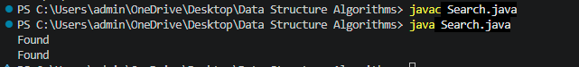
3: Sorting Customer Orders
class Order {
int id;
String customer;
double price;
Order(int id, String customer, double price) {
this.id = id;
this.customer = customer;
this.price = price;
}
}
public class Sorting {
static void bubbleSort(Order arr[]) {
for (int i = 0; i < arr.length - 1; i++) {
for (int j = 0; j < arr.length - i - 1; j++) {
if (arr[j].price > arr[j + 1].price) {
Order t = arr[j];
arr[j] = arr[j + 1];
arr[j + 1] = t;
}
}
}
}
static int partition(Order arr[], int low, int high) {
double pivot = arr[high].price;
int i = low - 1;
for (int j = low; j < high; j++) {
if (arr[j].price < pivot) {
i++;
Order t = arr[i];
arr[i] = arr[j];
arr[j] = t;
}
}
Order t = arr[i + 1];
arr[i + 1] = arr[high];
arr[high] = t;
return i + 1;
}
static void quickSort(Order arr[], int low, int high) {
if (low < high) {
int pi = partition(arr, low, high);
quickSort(arr, low, pi - 1);
quickSort(arr, pi + 1, high);
}
}
public static void main(String args[]) {
Order arr[] = {
new Order(1, "A", 500),
new Order(2, "B", 200),
new Order(3, "C", 800)
};
quickSort(arr, 0, arr.length - 1);
for (Order o : arr)
System.out.println(o.id + " " + o.price);
}
}
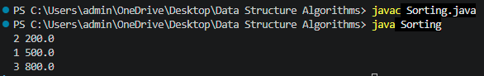

4: Employee Management System
class Employee {
int id;
String name;
String position;
double salary;
Employee(int id, String name, String position, double salary) {
this.id = id;
this.name = name;
this.position = position;
this.salary = salary;
}
}
public class EmployeeManagement {
public static void main(String args[]) {
Employee emp[] = new Employee[5];
emp[0] = new Employee(1, "Ram", "Manager", 50000);
emp[1] = new Employee(2, "Ravi", "Developer", 40000);
// Traverse
for (Employee e : emp) {
if (e != null)
System.out.println(e.id + " " + e.name);
}
// Search
int key = 2;
for (Employee e : emp) {
if (e != null && e.id == key)
System.out.println("Found " + e.name);
}
// Delete
emp[1] = null;
}
}
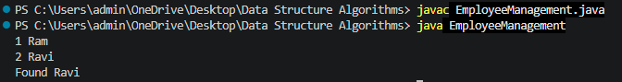

5: Task Management System
class Task {
int taskId;
String taskName;
String status;
Task next;
Task(int id, String name, String status) {
taskId = id;
taskName = name;
this.status = status;
}
}
public class SingleyLinkedList {
static Task head = null;
static void add(int id, String name, String status) {
Task t = new Task(id, name, status);
if (head == null)
head = t;
else {
Task temp = head;
while (temp.next != null)
temp = temp.next;
temp.next = t;
}
}
static void search(int id) {
Task temp = head;
while (temp != null) {
if (temp.taskId == id) {
System.out.println("Task Found");
System.out.println(temp.taskId + " " + temp.taskName + " " + temp.status);
return;
}
temp = temp.next;
}
System.out.println("Task Not Found");
}
static void display() {
Task temp = head;
while (temp != null) {
System.out.println(temp.taskId + " " + temp.taskName + " " + temp.status);
temp = temp.next;
}
}
static void delete(int id) {
if (head == null)
return;
if (head.taskId == id) {
head = head.next;
return;
}
Task temp = head;
while (temp.next != null && temp.next.taskId != id)
temp = temp.next;
if (temp.next != null)
temp.next = temp.next.next;
}
public static void main(String[] args) {
add(1, "Coding", "Pending");
add(2, "Testing", "Completed");
add(3, "Debugging", "Pending");
System.out.println("Task List:");
display();
search(2);
delete(2);
System.out.println("\nAfter Deletion:");
display();
}
}
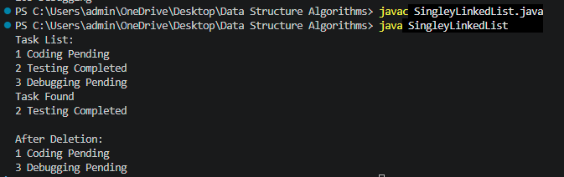

6: Library Management System
import java.util.Arrays;
import java.util.Comparator;
class Book {
int bookId;
String title;
String author;
Book(int id, String title, String author) {
bookId = id;
this.title = title;
this.author = author;
}
}
public class LibraryManagment {
static void linearSearch(Book b[], String key) {
for (Book x : b) {
if (x.title.equalsIgnoreCase(key)) {
System.out.println("Book Found: " + x.title);
return;
}
}
System.out.println("Book Not Found");
}
static void binarySearch(Book b[], String key) {
int low = 0, high = b.length - 1;
while (low <= high) {
int mid = (low + high) / 2;
int c = b[mid].title.compareToIgnoreCase(key);
if (c == 0) {
System.out.println("Book Found: " + b[mid].title);
return;
} else if (c < 0)
low = mid + 1;
else
high = mid - 1;
}
System.out.println("Book Not Found");
}
public static void main(String[] args) {
Book books[] = {
new Book(1, "C", "Dennis"),
new Book(2, "Java", "James"),
new Book(3, "Python", "Guido"),
new Book(4, "SQL", "Oracle")
};
System.out.println("Linear Search:");
linearSearch(books, "Python");
Arrays.sort(books, Comparator.comparing(a -> a.title));
System.out.println("Binary Search:");
binarySearch(books, "Python");
}
}
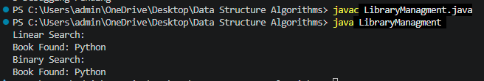

7: Financial Forecasting
public class Forecasting {
static double futureValue(double amount, double rate, int years) {
if (years == 0)
return amount;
return futureValue(amount * (1 + rate), rate, years - 1);
}
public static void main(String[] args) {
double principal = 10000;
double growthRate = 0.10;
int years = 5;
double result = futureValue(principal, growthRate, years);
System.out.println("Future Value = " + result);
}
}

